Leveraging DevOps, AI, Blockchain, Cloud-Native Architecture, and Microservices for SmartMed’s Healthcare Innovation

Introduction
SmartMed, an innovative healthcare technology startup, is poised to transform patient care through the strategic use of cutting-edge digital tools and methodologies. The company’s primary goal is to deliver healthcare solutions that are secure, scalable, and efficient, while maintaining seamless deployment, robust data integrity, and advanced predictive analytics. To achieve these objectives, SmartMed must integrate DevOps principles, automation platforms such as Jenkins, AI-driven development processes, blockchain-based security, cloud-native design, and microservices architecture. This essay explores how SmartMed can effectively employ these technologies and practices to optimize its operations, increase productivity, and ensure better patient outcomes. The following sections examine each of these crucial elements and their collective value for a forward-thinking healthcare technology enterprise.

DevOps principles and Jenkins automation
DevOps practices form the cornerstone for SmartMed to achieve rapid, reliable, and repeatable software delivery. The core of DevOps is the collaboration between development and operations teams, continuous integration and deployment, and automation throughout the software development lifecycle. Jenkins, a widely adopted open-source automation server, plays a key role in enabling developers to build, test, and deploy applications with efficiency (Codefresh OSS Team, 2025). By implementing Jenkins pipelines, SmartMed can codify deployment workflows, automate testing and validation, and integrate with a range of tools within the DevOps toolchain, which ensures consistency and minimizes the risk of human error. Jenkins is flexible enough to operate in different environments, whether on-premises or in the cloud, and it supports various operating systems, making it suitable for projects with diverse infrastructure requirements (Codefresh OSS Team, 2025). For instance, a typical Jenkins pipeline at SmartMed might include automated code builds, execution of unit tests, security verifications, and deployment to staging or production environments. Automating these processes shortens release cycles and increases system reliability, which is especially important for healthcare applications that require high availability and regulatory compliance. With a strong DevOps foundation established, SmartMed can further enhance its productivity and innovation by embracing AI-driven software development, particularly for implementing predictive analytics in patient care.

AI-Driven development for predictive analytics
Artificial intelligence is quickly transforming the software development lifecycle by offering tools that can automate code generation, documentation, testing, and even architectural design. For SmartMed, adopting an AI-driven development life cycle means positioning AI as an active collaborator throughout the software process. This methodology not only accelerates development speed but also improves the quality and consistency of healthcare solutions (Raja, 2025). In the field of predictive analytics, AI can analyze extensive datasets to forecast patient outcomes, identify anomalies, and suggest individualized treatments, significantly advancing patient care and operational efficiency. SmartMed can leverage AI-powered execution combined with human oversight, which allows AI to generate detailed work plans and code while clinicians and engineers validate both clinical relevance and regulatory compliance. The dynamic team collaboration engendered by AI-driven development fosters creative problem-solving and swift decision-making, empowering SmartMed to respond rapidly to the ever-evolving healthcare landscape (Raja, 2025). By maintaining a persistent context across all development phases, AI ensures continuity and traceability, both of which are essential for compliance within healthcare environments. Although AI provides substantial productivity and innovation benefits, the security and integrity of sensitive patient data remain critical concerns. This necessity brings into focus the importance of blockchain technology and its foundational components for SmartMed’s operations. This holistic redesign should ultimately accelerate the process, improve product quality, increase customer adoption and satisfaction, and spur greater innovation (Figures 1 and 2).
Figure 1:
Current software product development life cycle
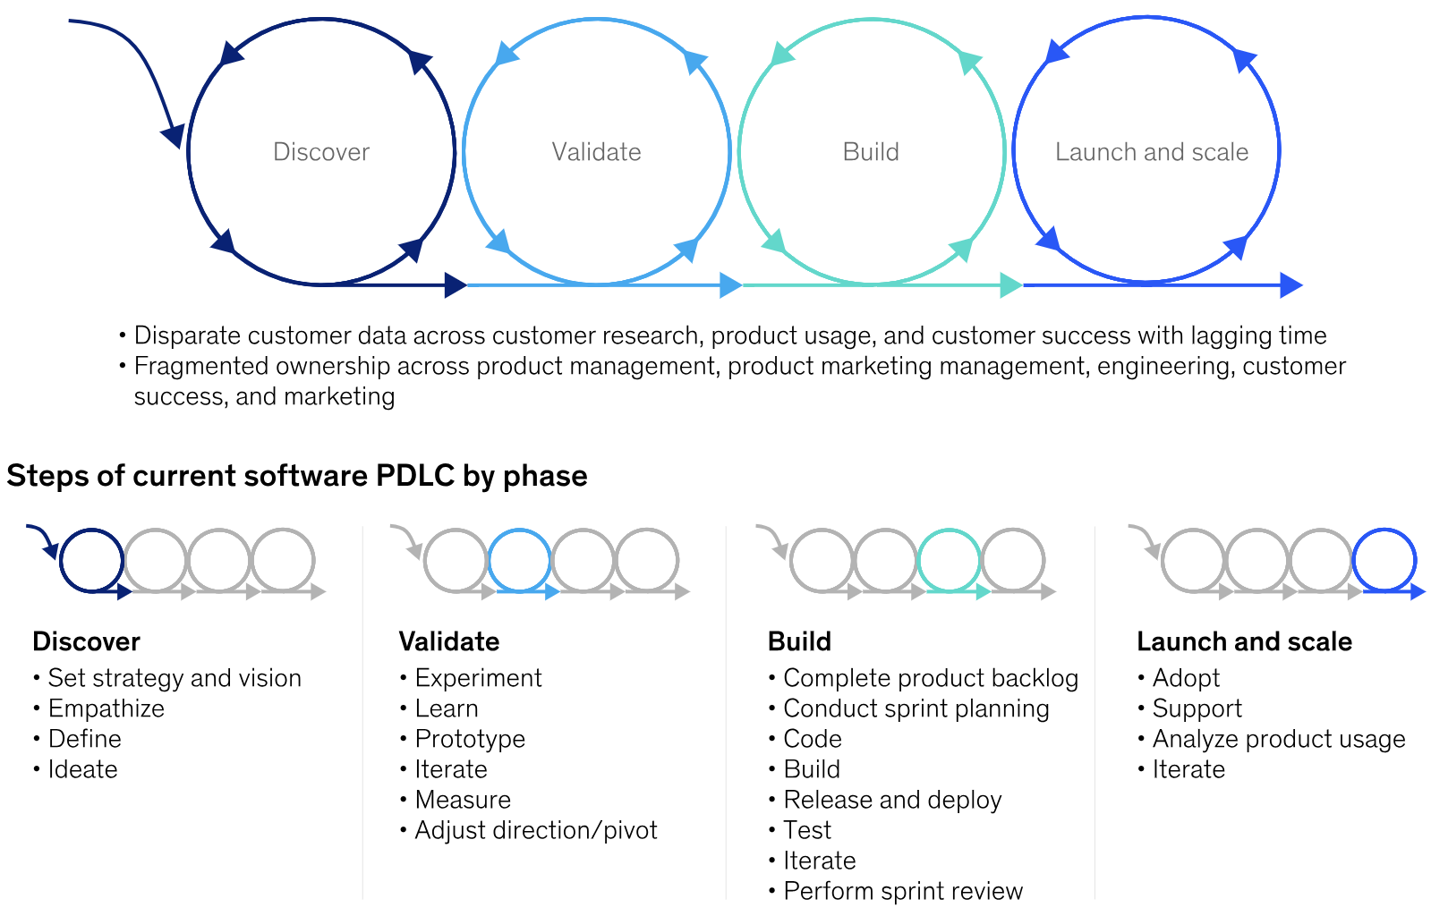
Figure 2
AI-enabled software product development life cycle
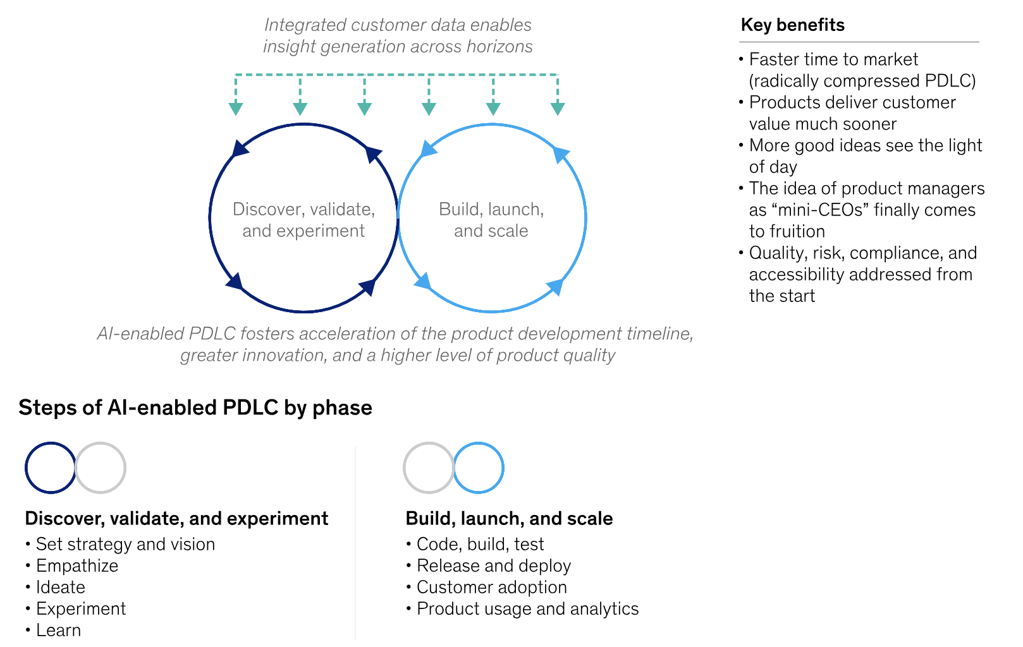

Blockchain components for secure record-keeping
Blockchain technology offers a robust framework for secure, transparent, and unalterable data management, which is especially important in healthcare for maintaining patient records and guaranteeing data privacy. The foundational components of a blockchain network are blocks, nodes, and consensus mechanisms (Davis, 2023). Each block securely contains encrypted patient data and is chronologically linked to form a verifiable history of medical events. Nodes, which are distributed across SmartMed’s network, hold complete copies of the blockchain and are responsible for validating new data entries, thus ensuring consistency and resilience against data loss or tampering. The consensus mechanism, such as proof of work or proof of stake, enables the network to validate transactions without dependence on a central authority (Davis, 2023). Other key elements include cryptographic hashing, digital signatures, and smart contracts. These features ensure that only authorized individuals can access or modify records and allow for the automation of clinical workflows that are both auditable and secure. By integrating blockchain into its infrastructure, SmartMed not only protects patient data but also establishes a foundation of trust for stakeholders and regulatory authorities.

Cloud-native architecture for scalability
A cloud-native architecture lays the groundwork for applications that can scale, recover quickly from failures, and adapt to changing requirements in the healthcare sector. In contrast to traditional monolithic systems, cloud-native designs make use of modular components that can be independently deployed and managed (Okta, 2024). Central features of this architecture include containers, which encapsulate application components along with their dependencies; immutable infrastructure, in which system components are replaced rather than modified; microservices, which separate the application into discrete, independently deployable services; and service meshes that facilitate secure and reliable communication among services. By applying cloud-native principles, SmartMed ensures that its applications can respond to increases in patient data, recover rapidly from outages, and undergo updates or improvements without disrupting ongoing operations (Okta, 2024). This architectural adaptability is crucial for supporting continuous innovation and for smoothly integrating new features such as AI and blockchain into the healthcare platform.

Microservices components for efficient operations
Microservices architecture divides applications into several small, loosely coupled services, each responsible for a specific business function. This modular structure permits SmartMed to develop, deploy, and scale individual components independently, which improves fault tolerance and supports rapid innovation (Xu, 2024). Key microservices components for SmartMed include the API gateway, which acts as the unified entry point for client applications and manages routing, filtering, and load balancing (Figure 3). The service registry keeps track of all available services and allows the gateway to discover them dynamically. The service layer organizes microservices to address distinct healthcare processes like patient registration, appointment scheduling, or analytics. Security is ensured by the authorization server, which manages identity and access control, while data storage solutions such as PostgreSQL and MySQL handle the large volumes of patient data generated. Distributed caching solutions like Redis increase application performance, and asynchronous communication platforms like Kafka enable real-time data exchange between services. Effective monitoring is achieved through metrics visualization tools such as Prometheus and Grafana, while log aggregation and visualization tools like Elasticsearch and Kibana support proactive system management and regulatory compliance (Xu, 2024). Integrating these advanced technologies and practices positions SmartMed to deliver healthcare solutions that are secure, scalable, and at the forefront of digital innovation.
Figure 3
Essential components of a production microservice application
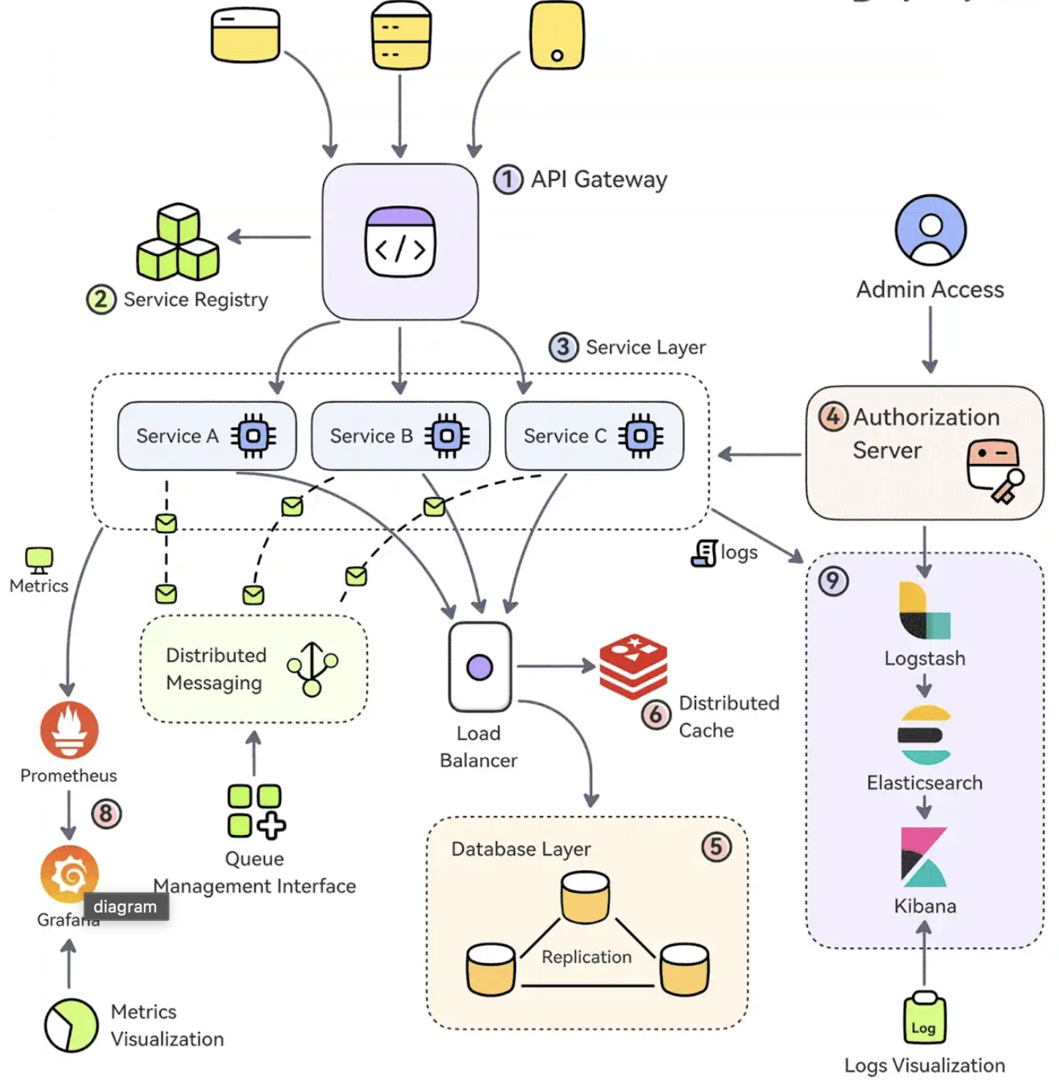

Conclusion
SmartMed’s comprehensive integration of DevOps principles, Jenkins automation, AI-driven development, blockchain security, cloud-native architecture, and microservices design forms a solid blueprint for healthcare innovation. DevOps and Jenkins ensure streamlined and reliable deployments. AI-driven development boosts productivity and enhances predictive patient care. Blockchain technology secures patient data and builds trust. Cloud-native architecture delivers scalability and resilience, while microservices provide modularity and operational efficiency. By uniting these technologies, SmartMed is well-positioned to address the dynamic challenges of modern healthcare, ensuring top-tier patient outcomes, regulatory compliance, and long-term competitive advantage. This holistic approach empowers SmartMed to lead the digital transformation of healthcare delivery, setting new benchmarks for security, scalability, and patient-focused innovation.
References
Codefresh OSS Team. (2025, April 7). CI/CD with Jenkins in 3 steps. Codefresh. https://codefresh.io/learn/jenkins/ci-cd-with-jenkins-in-3-steps/
Davis J. (2023, February 12). What are the 3 Key Components Of The Blockchain Network? Iglu. https://iglu.net/key-components-of-the-blockchain-network/
Okta. (2024, November 21). Cloud-native architecture: A guide, definitions, types & more. https://www.okta.com/identity-101/what-is-cloud-native-architecture/
Raja. (2025, July 31). AI-driven development life cycle: Reimagining software engineering. Amazon Web Services. https://aws.amazon.com/blogs/devops/ai-driven-development-life-cycle/
Xu A. (2024, July 20). EP121: 9 essential components of a production Microservice application. ByteByteGo. https://blog.bytebytego.com/p/ep121-9-essential-components-of-a

